VNP Documentation

1….Introduction

2…Command List

Introduction

VNP is a Visual Novel framework developed for Unity 2021.3.18f1 by myself. It supports all major visual novel features, specific ones will be tailored according to the game needs. It is modular and really easy to add more content and features to, such as new commands and new effects.

VNP: it is what I decided to call the scripting language for the scenes. It uses simple syntax and tries to keep the document as easy to read as possible.
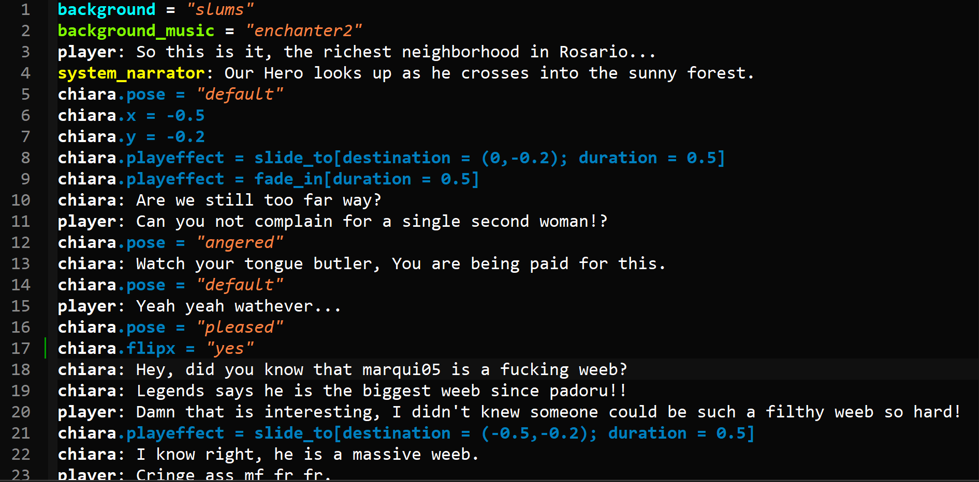

Use # to define comments.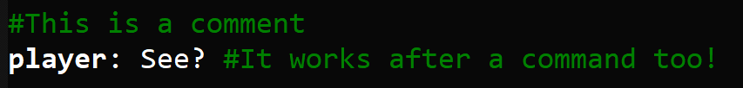
Command List
Basic structure: <command> <operator> <arguments>

Dialogue - Makes characters speak.

character_id: dialogue

Narrator Dialogue - Creates a system speak command.
system_narrator: dialogue

Background Change - Changes the scene background abruptly.

background = “background_image_name”

Move Character - Changes the character position abruptly, the values are normalized in all axes.

character_id.axis = ”position_as_float”
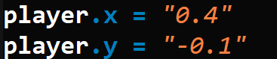
The minimum and maximum value for both axes is -1 and 1 respectively, with -1 being left/bottom, and 1 being right/top

Change Pose - Changes the pose of the character abruptly.

character_id.pose = ”pose_file_name”
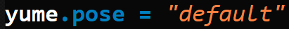

You can make use of the keyword hide to hide the character again.


Flip Character - Changes the orientation of the character smoothly.

character_id.flipx = ”yes/no”
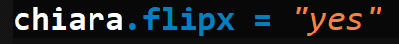

You can also use character_id.flipxsnap = ”yes/no” to instantly change the orientation without smoothing.

